Jerry Vargas

Caitlyn Bowen

Jonah Schrum

Final ERD

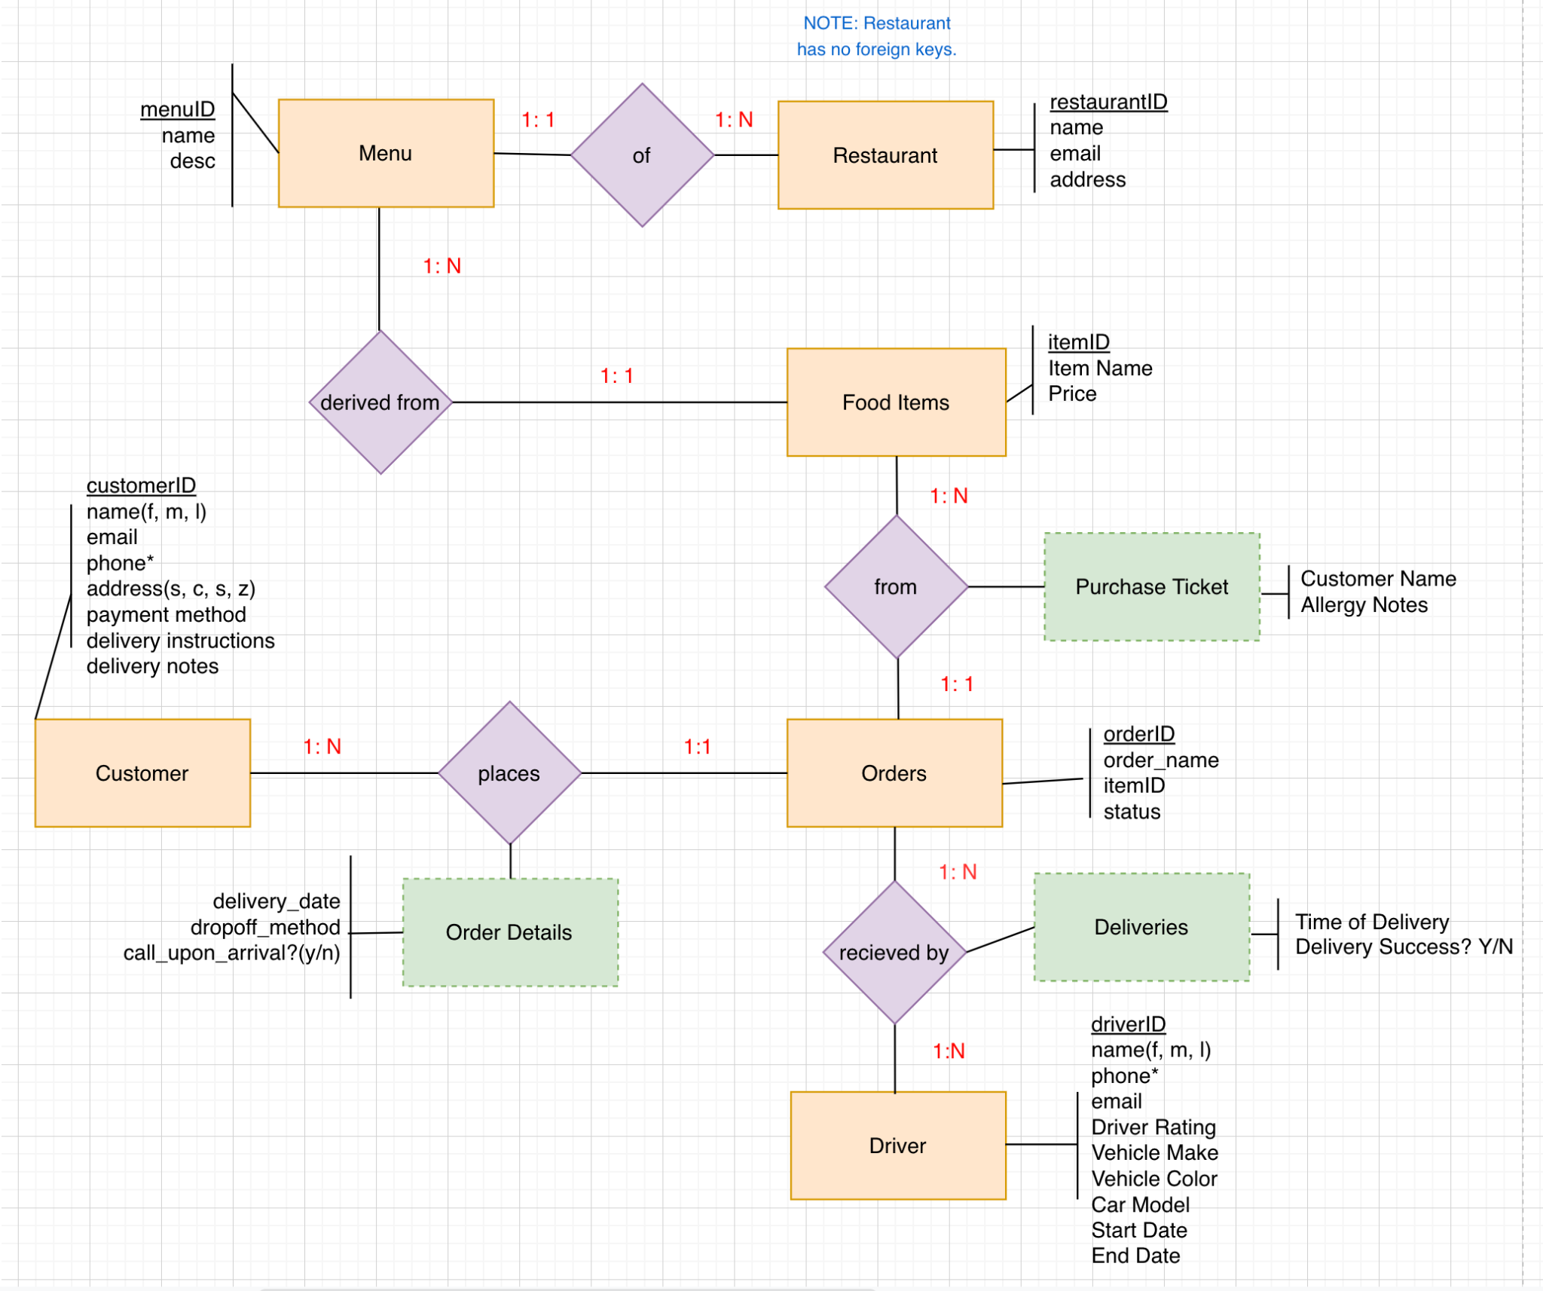

Final Conversions

Orders(orderID, order_name, status, itemID→)

Driver(driverID, driver_fname, driver_mname, driver_lname, start_date, end_date, driver_phone, driver_email, driver_rating, vehicle_color, vehicle_make, car_model)

Customer(customerID, cust_fname, cust_mname, cust_lname, cust_email, addr_street, addr_city, addr_state, addr_zip, payment_method, delivery_instructions, delivery_notes)

Customer_phone(customerID->, cust_phone)

Food Items(ItemID, item_name, price, menuID→)

Menu(menuID, menu_name, menu_desc, restaurantID→)

Restaurant(restaurantID, rest_name, rest_email, rest_address)

Purchase_ticket(orderID →, itemID →, customer_name, allergy_notes)

Deliveries(orderID→, driverID→, delivery_time, delivery_sucess_y_or_n)

Order Details(delivery_date, dropoff_method, call_upon_arrival_y_n, orderID→, customerID→)